Practice Assessment - Git and Git Hub

Name: S.Mohamed Suhail

Hero Vired ID: 12777

Git Hub Link - https://github.com/suhailm67-sys/Practice-Assignment-on-Testing-Linux-and-Servers.git

Note: Refer Readme notes for implemented steps for completing the assignment and logs are also uploaded in the GitHub link.

Task 1: System Monitoring Setup
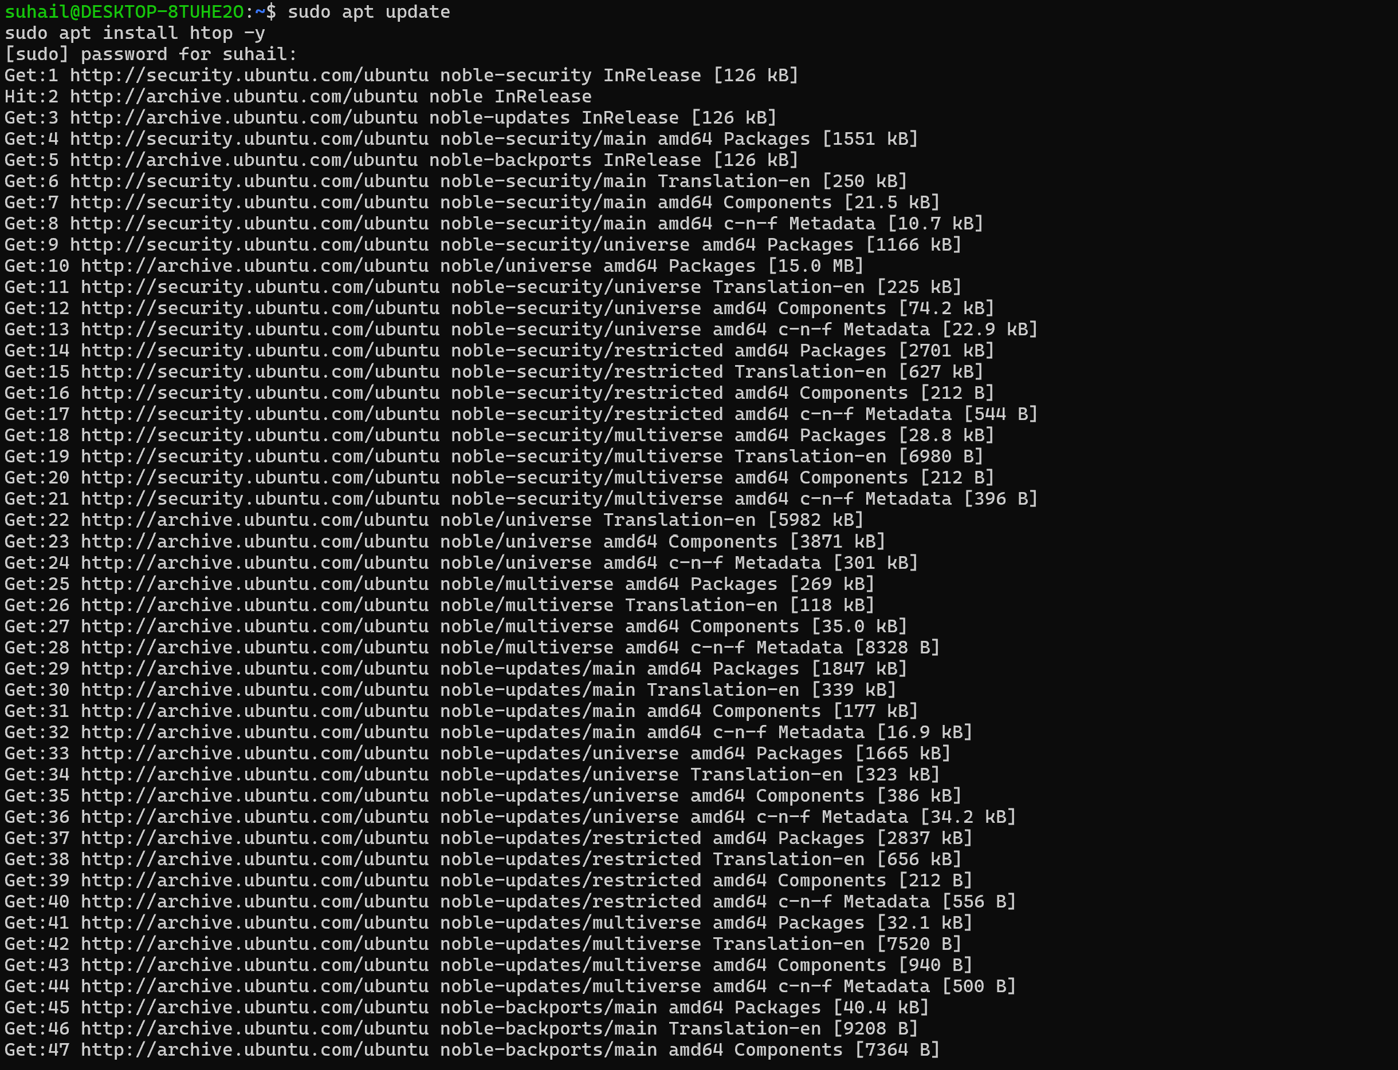

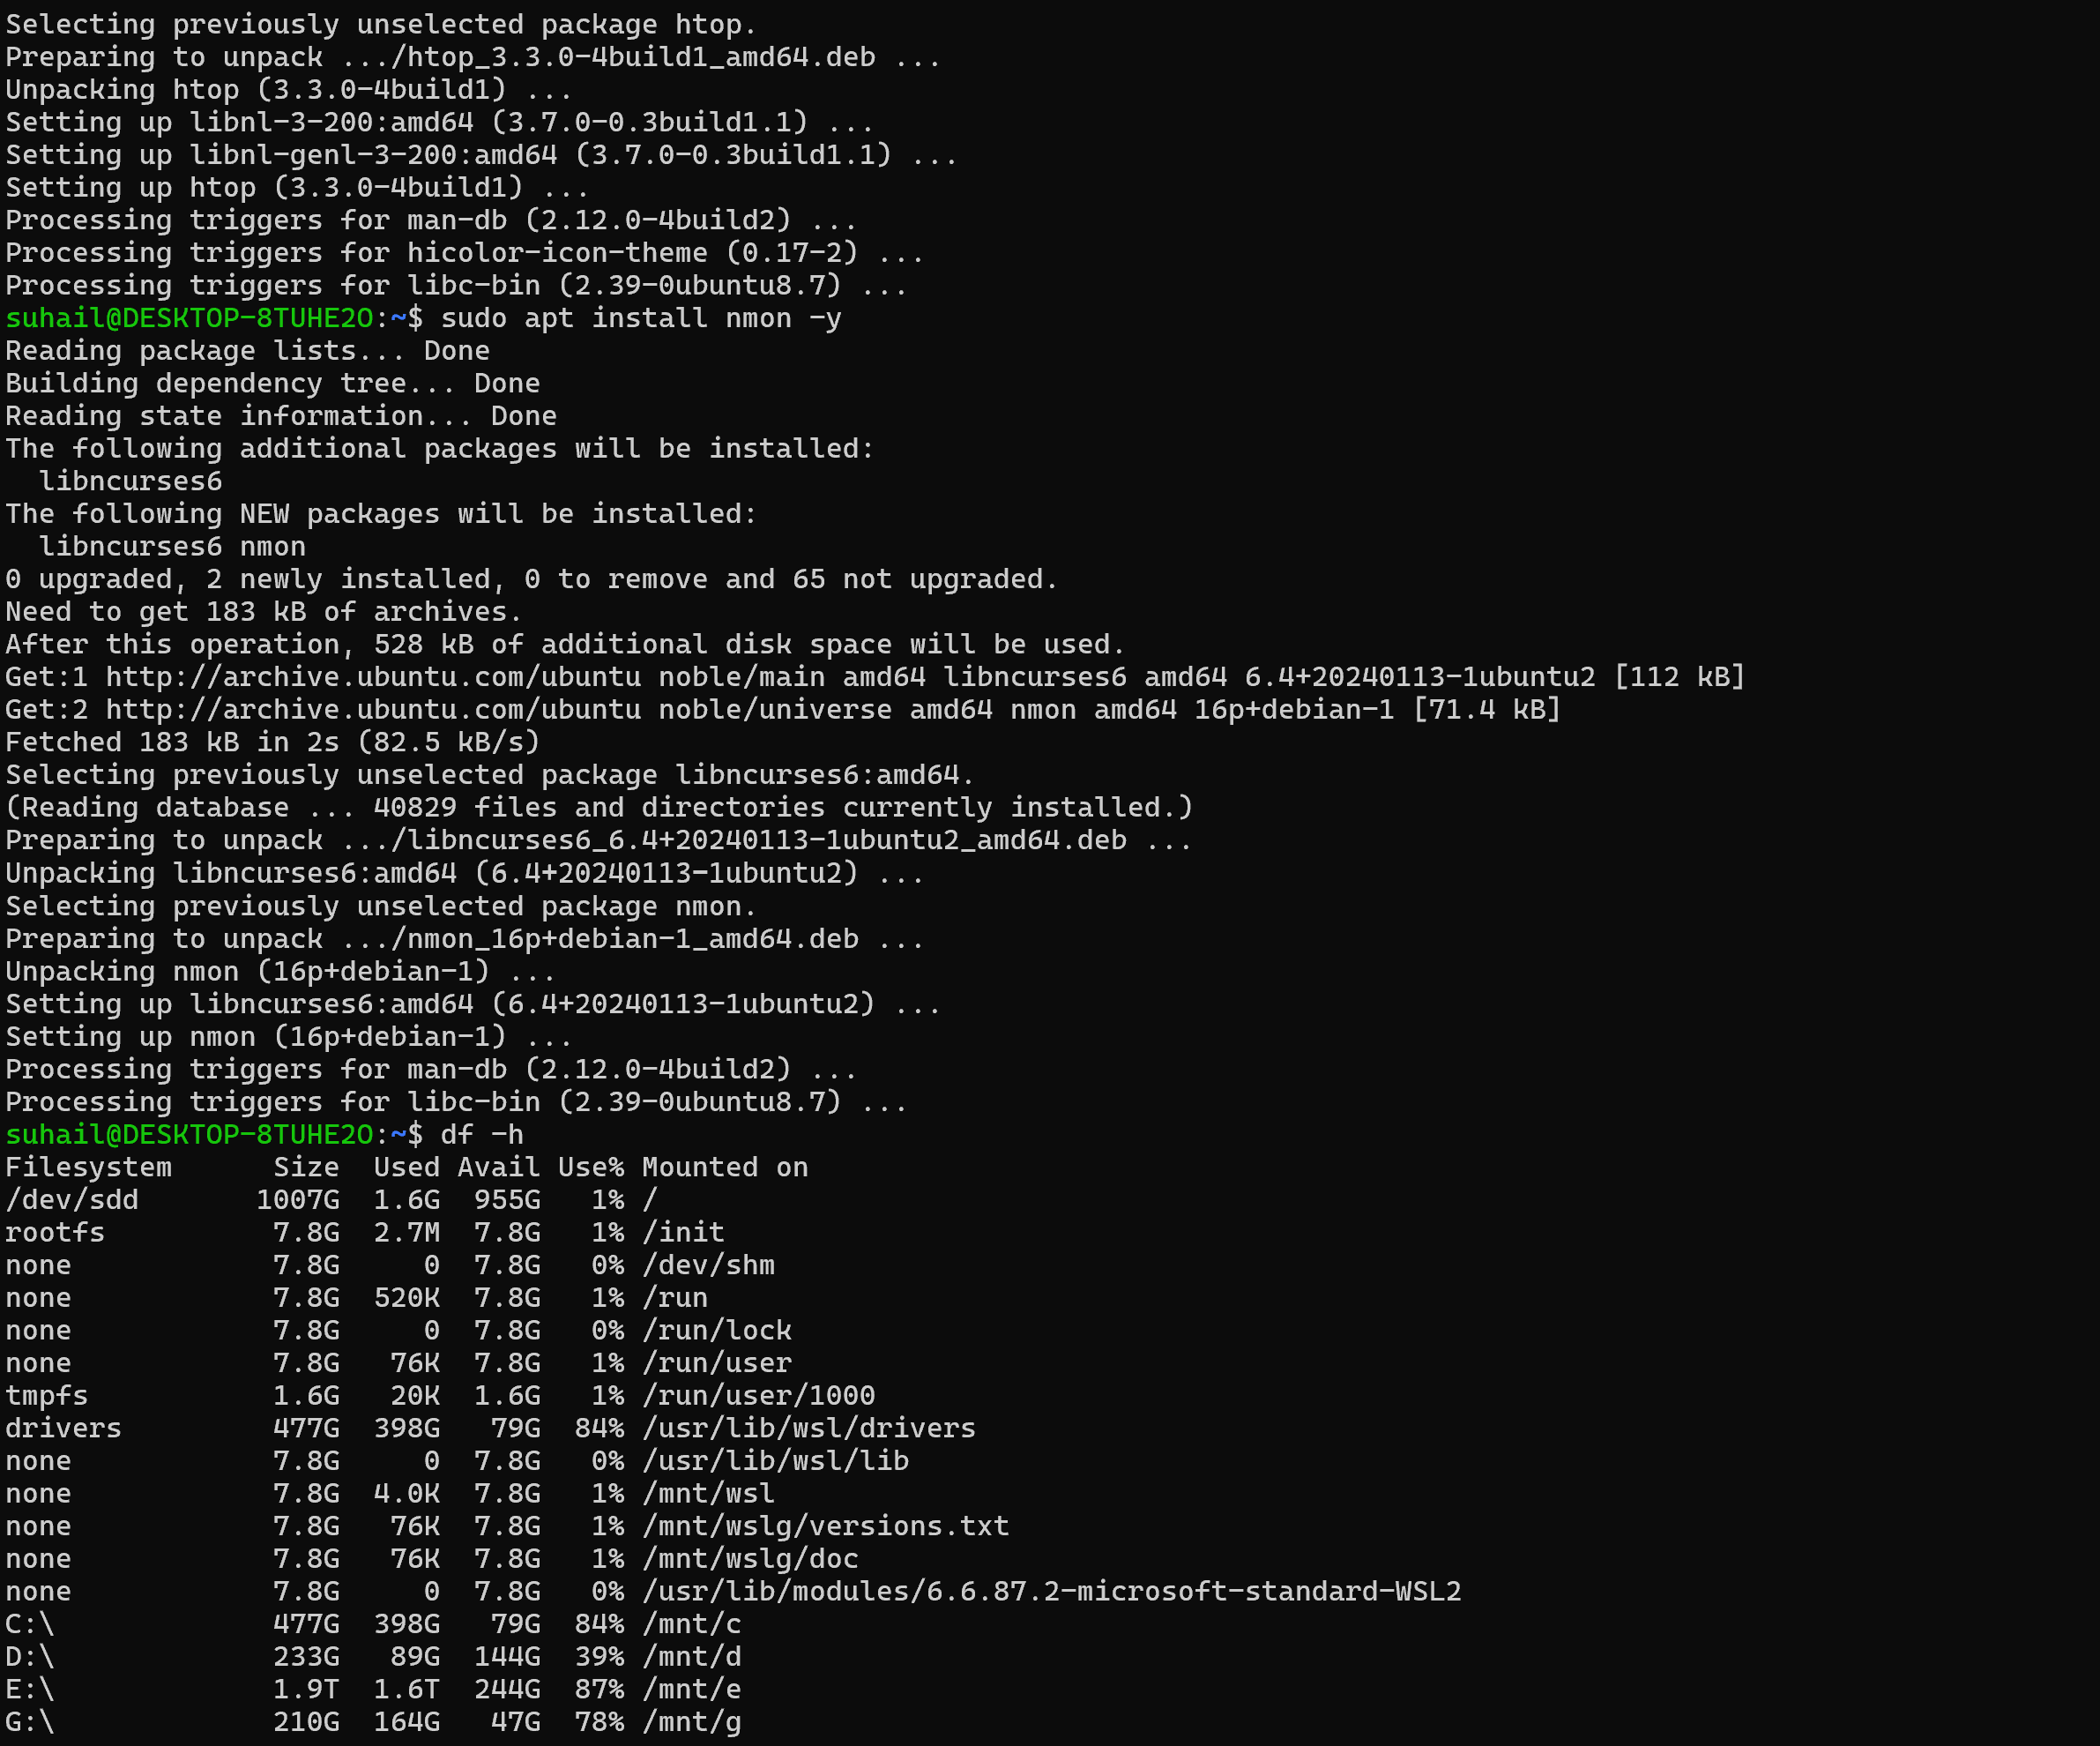
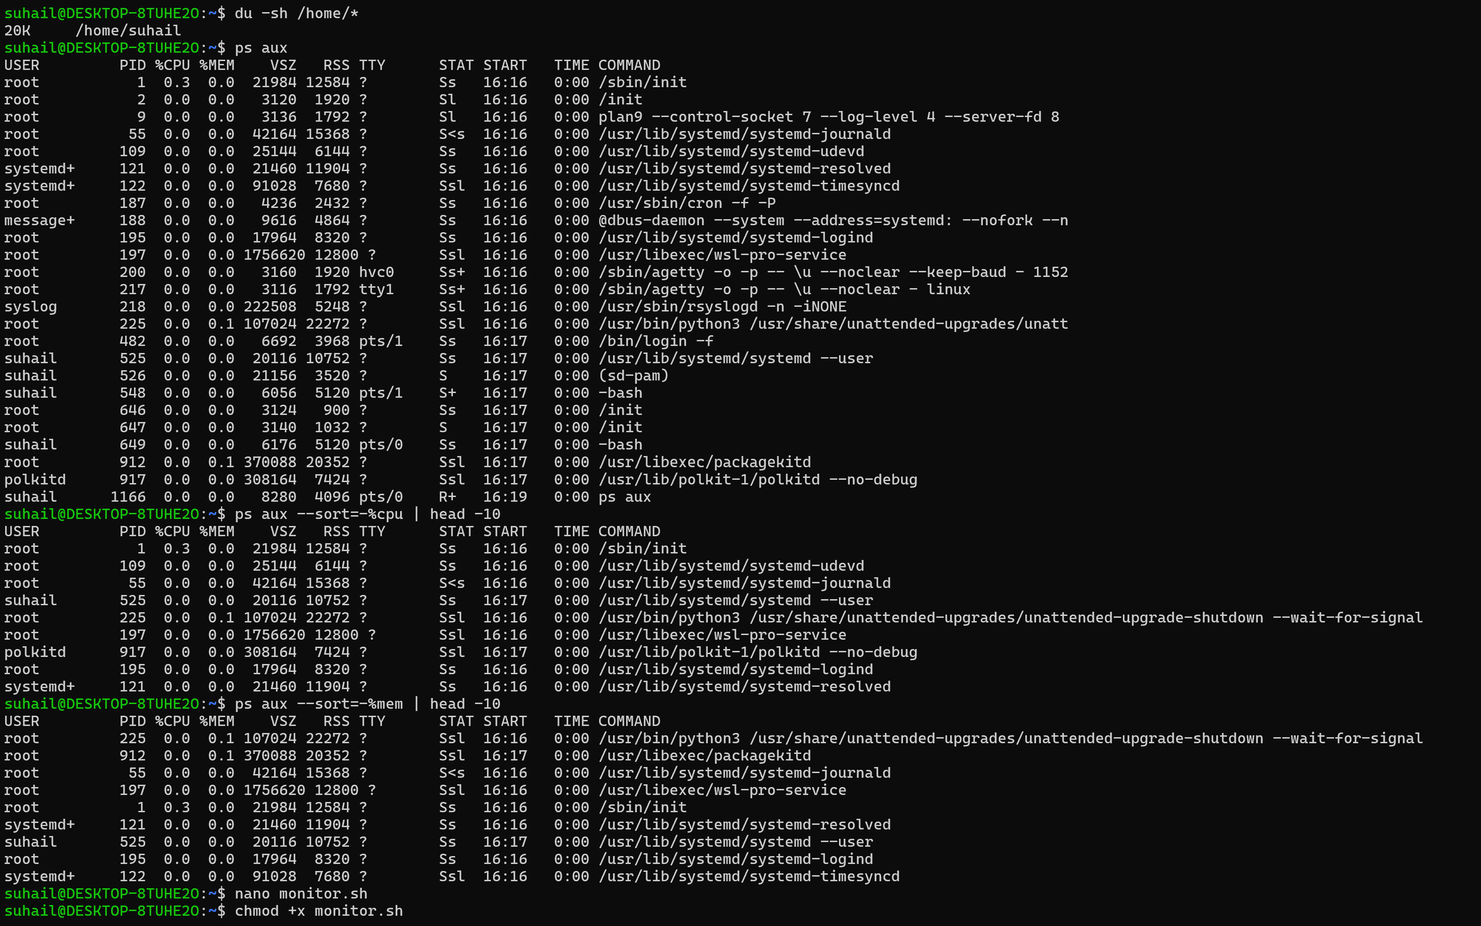
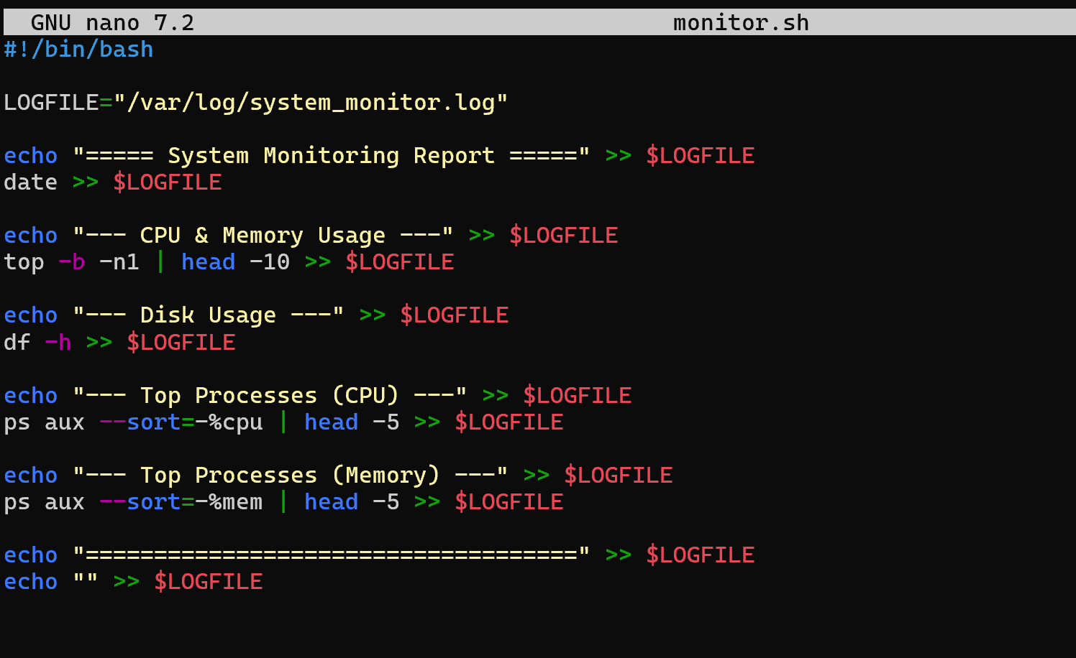
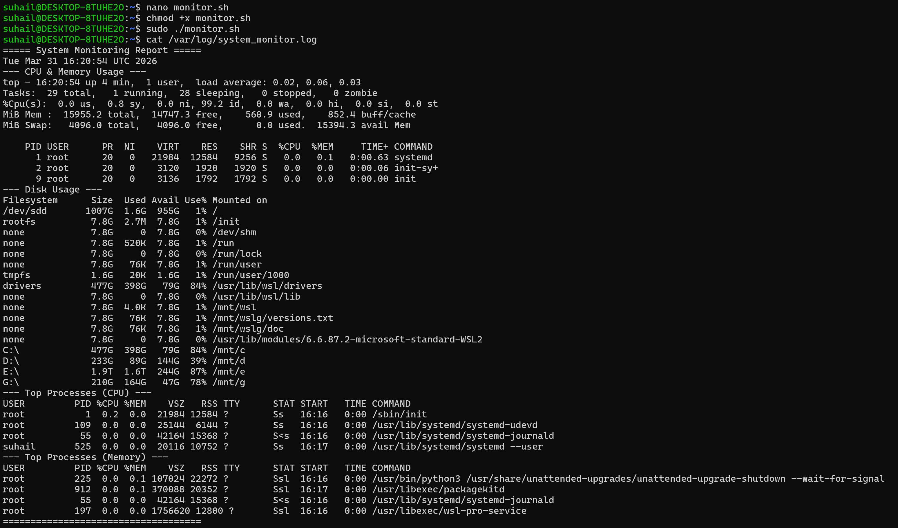
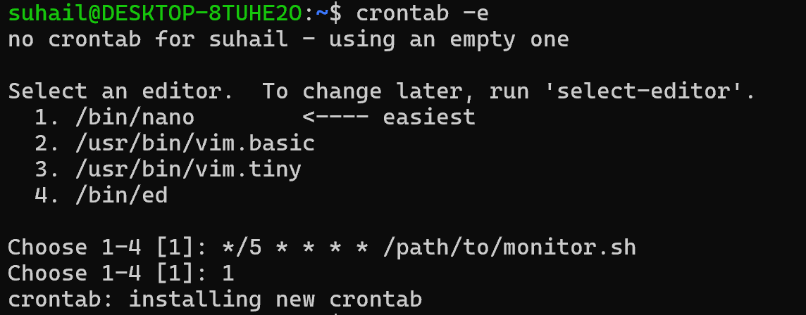

Task 2: User Management and Access Control
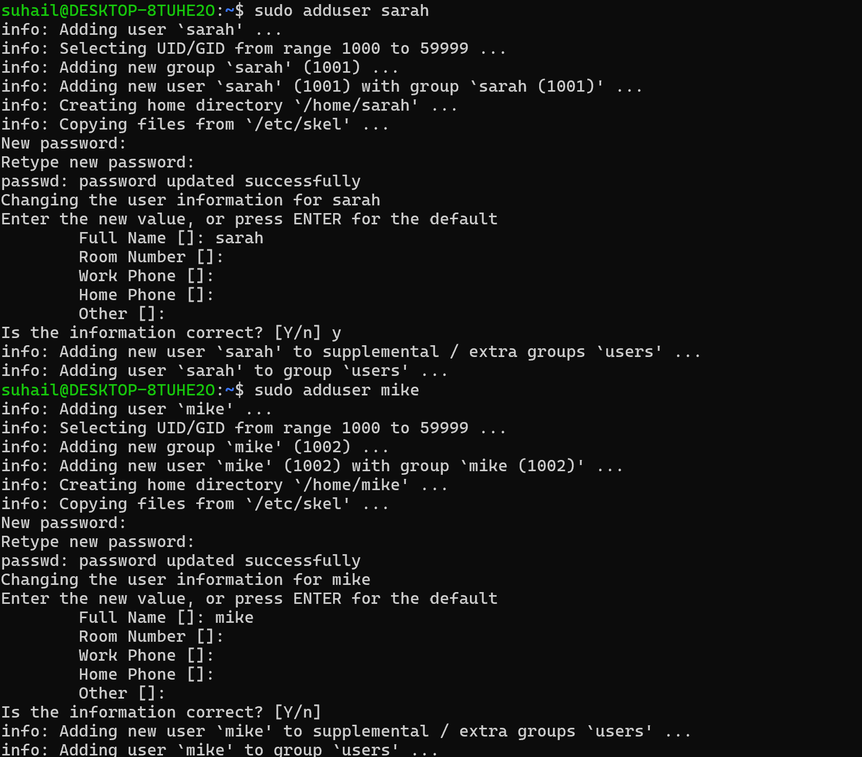

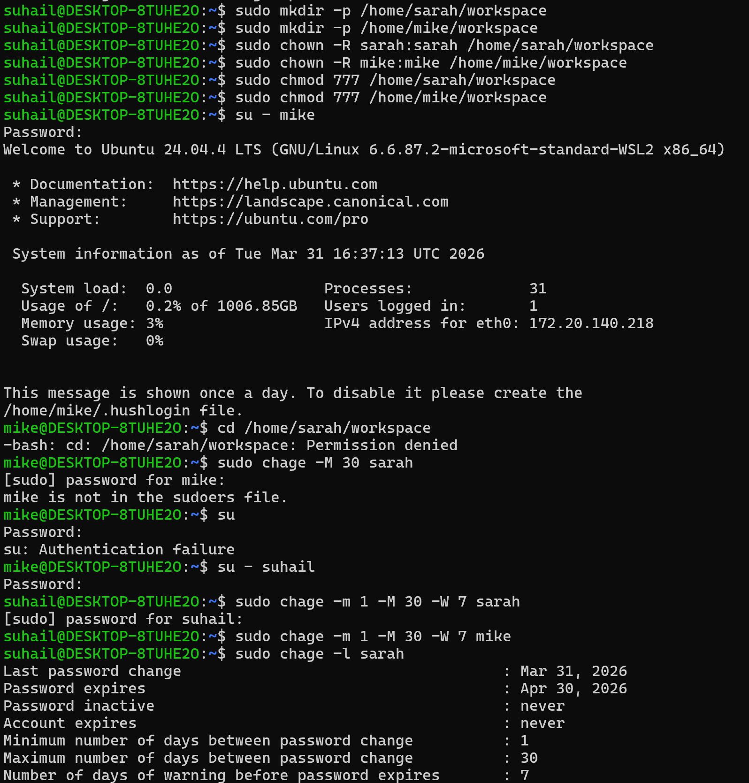

Task 3: Backup Configuration for Web Servers

